Super User :

User name = admin

Password : admin

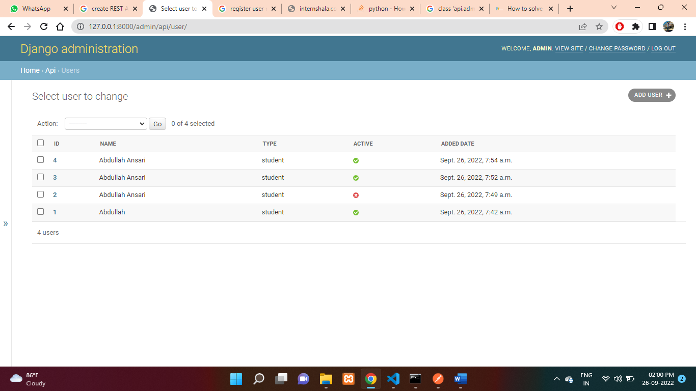

API

Method :- POST

<URL:-> <http://127.0.0.1:8000/api/user/>

Raw data :- Request

{

    "name": "Rahul Sharma",

    "type": "teacher",

    "active": **true**

}

Response :-

{

"url": "http://127.0.0.1:8000/api/user/5/",

"id": 5,

"name": "Rahul Sharma",

"type": "teacher",

"added_date": "2022-09-26T08:31:17.317150Z",

"active": true

}

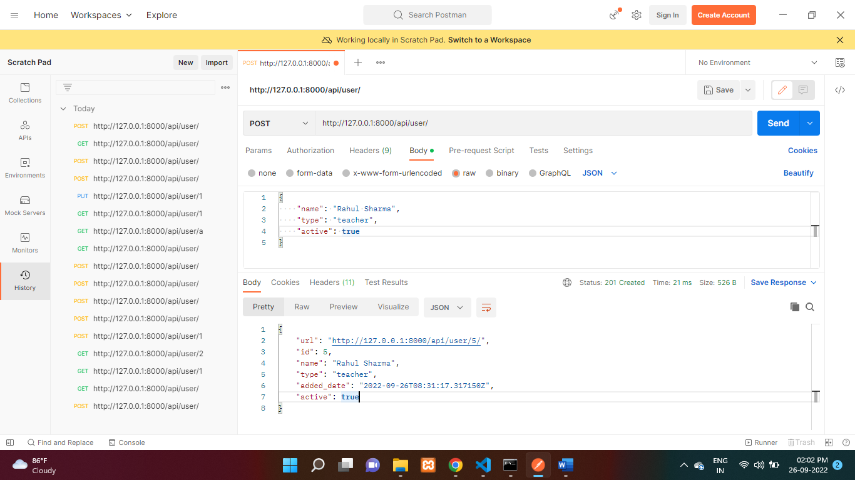

Method :- GET (All data)

<URL:-> <http://127.0.0.1:8000/api/user/>

Response :-

[

{

"url": "http://127.0.0.1:8000/api/user/1/",

"id": 1,

"name": "Abdullah",

"type": "student",

"added_date": "2022-09-26T07:42:52.263773Z",

"active": true

},

{

"url": "http://127.0.0.1:8000/api/user/2/",

"id": 2,

"name": "Abdullah Ansari",

"type": "student",

"added_date": "2022-09-26T07:49:13.820509Z",

"active": false

},

{

"url": "http://127.0.0.1:8000/api/user/3/",

"id": 3,

"name": "Abdullah Ansari",

"type": "student",

"added_date": "2022-09-26T07:52:38.934235Z",

"active": true

},

{

"url": "http://127.0.0.1:8000/api/user/4/",

"id": 4,

"name": "Abdullah Ansari",

"type": "student",

"added_date": "2022-09-26T07:54:18.805965Z",

"active": true

},

{

"url": "http://127.0.0.1:8000/api/user/5/",

"id": 5,

"name": "Rahul Sharma",

"type": "teacher",

"added_date": "2022-09-26T08:31:17.317150Z",

"active": true

}

]

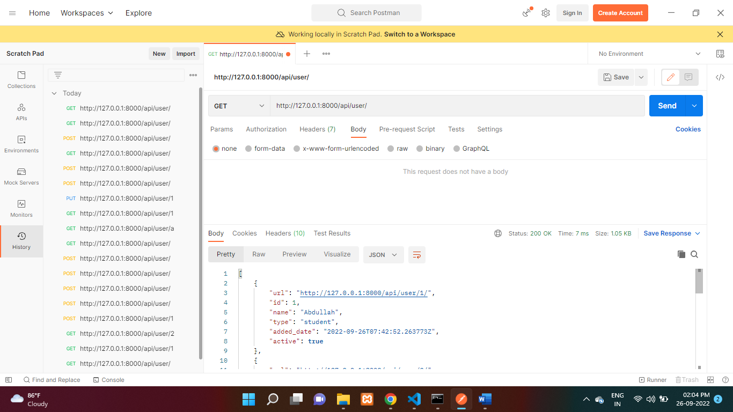

Method :- GET (by id)

<URL:-> <http://127.0.0.1:8000/api/user/2>

{

"url": "http://127.0.0.1:8000/api/user/2/",

"id": 2,

"name": "Abdullah Ansari",

"type": "student",

"added_date": "2022-09-26T07:49:13.820509Z",

"active": false

}

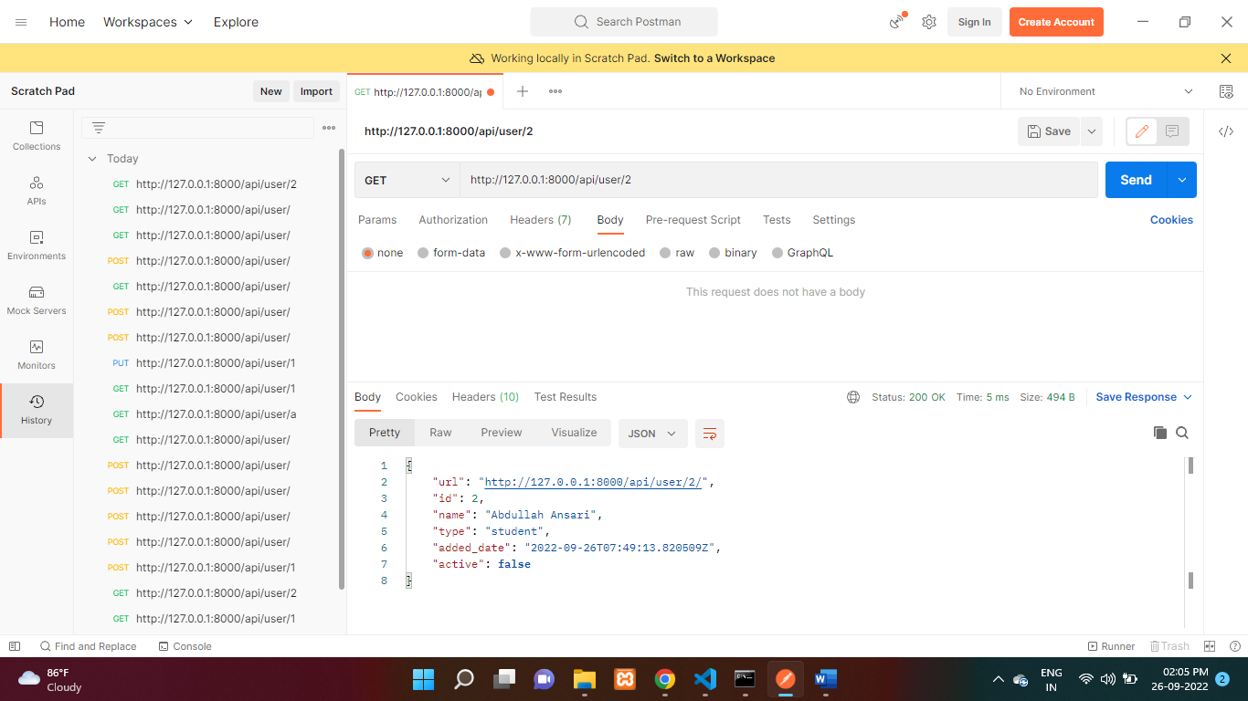

Method :- PUT

<URL:-> http://127.0.0.1:8000/api/user/3/

Request :-

{

    "name": "Rahul",

    "type": "teacher",

    "active": **true**

}

Response :-

{

"url": "http://127.0.0.1:8000/api/user/3/",

"id": 3,

"name": "Rahul",

"type": "teacher",

"added_date": "2022-09-26T08:38:19.319094Z",

"active": true

}

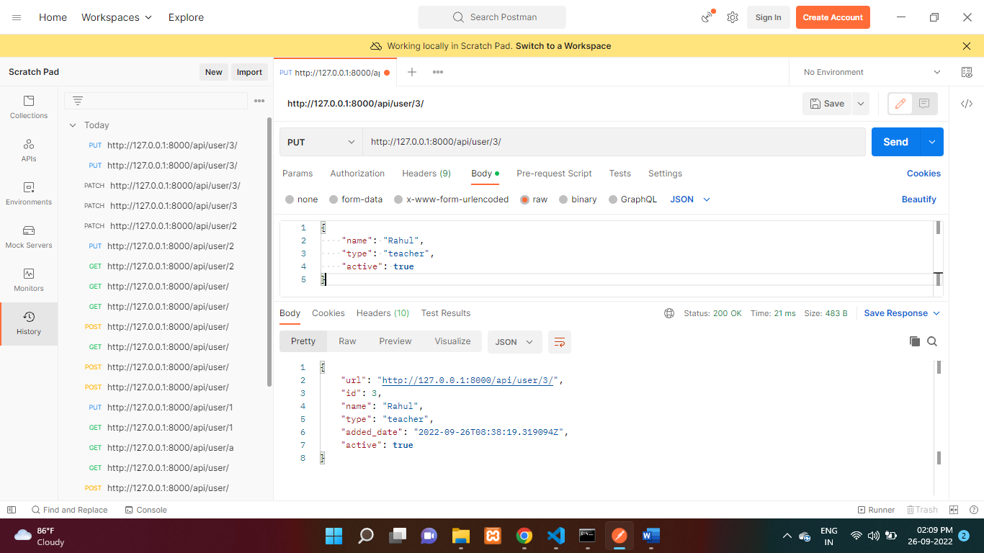

Method :- DELETE

<URL:-> http://127.0.0.1:8000/api/user/3/